1. 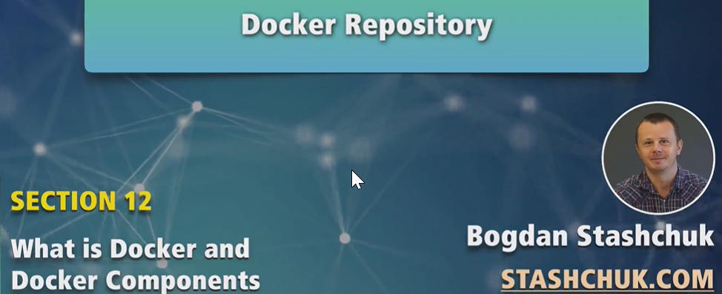
2. Now you know what is Docker image and Docker Container.

|  |  |
| --- | --- |
| Image | Container |
| Can’t be modified | Can be modified such as creating new files inside container. |
| Not running | Running image is called container. |

1. Docker Repository is same as git repository.
2. Docker repository is created with Docker images.
   1. A Docker repository can have different versions for the same image.
   2. Every Docker image has a tag by default it is named “latest” but we can assign different tags to different version of an image.
3. 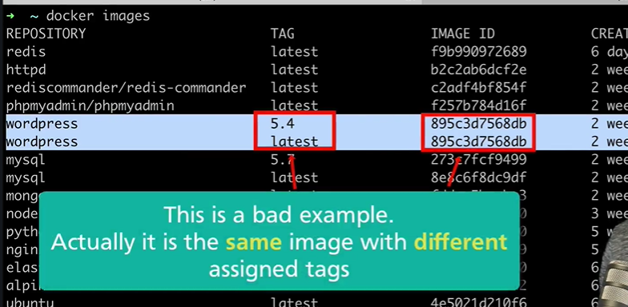
4. 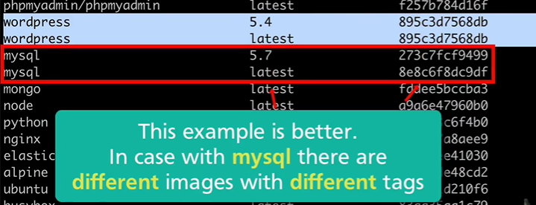
5. It means that these two images (mysql) belong to same repository because different versions for the same image are served by same repo.
6. These images are downloaded from the Docker hub.
   1. Docker Hub is one of Image Hosting Serivces.
7. Let’s talk about Docker Hub in next lecture.